5SAC SR – Points of Analysis and Context

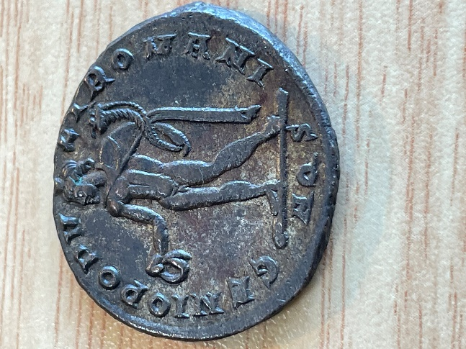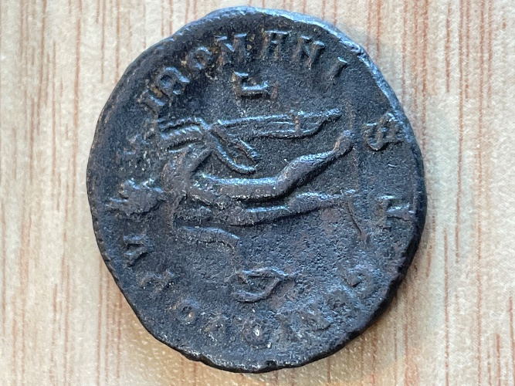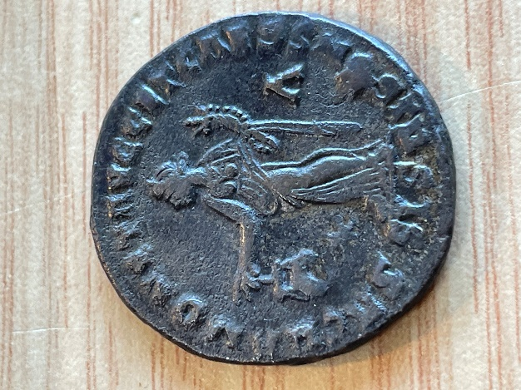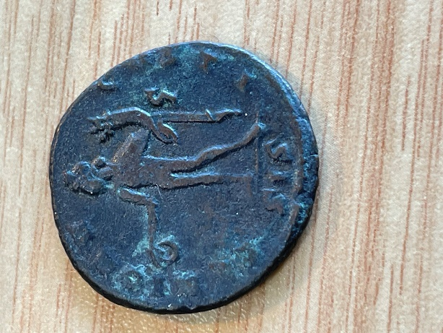**SISCIA**

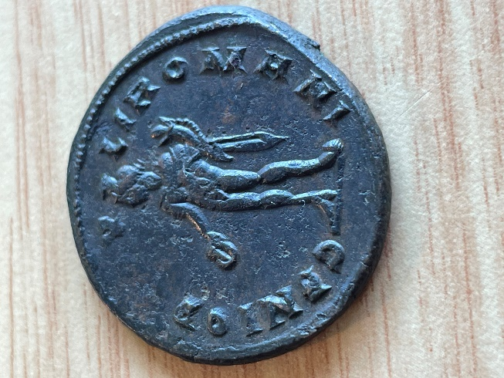**London**

**Unidentified**

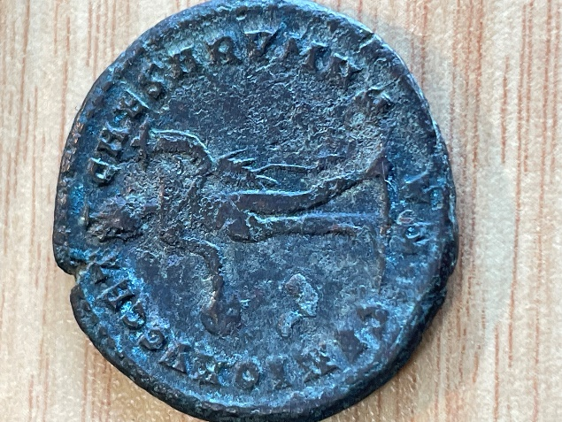

**Scan Process**

1. London Mint and Siscian 1 (1 & 5) to be scanned with XRF and RAMAN on the points specified.
2. All other coins, to be scanned with XRF on the point specified.
3. If possible, XRF field scan to be performed on the unidentified coin (6)